Module Name & Name of the Module

EBA5001 - Fundamental Certificate - Analytics Project Management

Title of Proposal

Analytics Proposal for GoRecruit

File name of the Document

EBA5001_Group10_Proposal

Date of Proposal

31st August 2020

Team Name

Oakridge Analytica

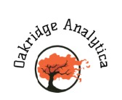

Team Members

Rupali Kumari (A0215284H)

Shivangi Verma (A0215504R)

Aayush Mathur (A0215470M)

Chaitanya Muthaiyan (A0215444L)

Rishabh Ambwani (A0215462L)

1. Introduction

We are **Oakridge Analytica**, analytics consulting company working in the areas of HR, Finance and Operations domains across the world. We help clients become data-driven organizations to achieve better performance more efficiently.

In this engagement, we will support GoRecruit Private Limited, one of the leading recruitment agencies, in **setting up a governance structure** for their recently created analytics wing. Simultaneously, part of our team will aid their data science recruitment arm to generate a **market assessment report** to be published on their website. The insights generated from the report will help GoRecruit target high-margin job postings based on revenue, salary, and location. The report will also help end users such as analytics professionals in job search by assessing their target companies based on ratings, salary, location, and competitors.

Through this engagement we are trying to update the expectations of recruitment companies as well as the current batch of graduating analytics professionals before they apply for job roles in their target companies.

1. Industry and Company Overview

GoRecruit Private Limited is one of the leading recruitment companies with 20 years in the recruitment market. They currently have 30 offices in the United States and are now expanding to other parts of the world as well, with strong opportunities for more growth within Asia Pacific. They currently have recruitment arms across spectrum of industries such as Financial Services, Oil & Gas, Digital and recently **created Data science arm.**

**Current organisation structure of GoRecruit: -**

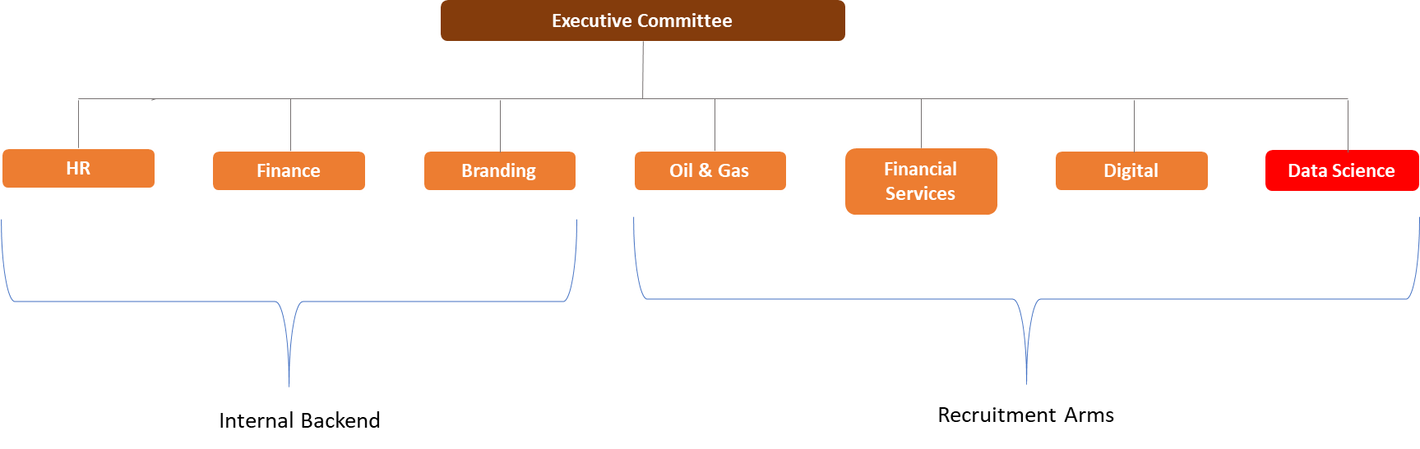

1. Business Problem & Objectives

GoRecruit wants to ameliorate their newly setup **analytics wing**, increase **profit margin** by targeting high-margin job postings, **bridge the gap** **between** analytics professionals and companies by publishing a market assessment report –

**Descriptive**

This engagement aims to create a holistic dashboard for the data science recruitment arm where we aim to provide users with the latest information about analytics jobs by salary and company ratings across different locations in USA. Some of the key areas we aim to visualize:

* **Map out salary distribution across locations**
* **Visualize top 20 salaries by industry**
* **Visualize salary by company age and more …**

In addition, we would like to include other information, such as the size of the company, year founded, industry and competitors.  We further plan to deliver market assessment report on data science jobs across various industrial spectrum for GoRecruit’s public domain to make people more aware and less vary for their job-hunting process.

**Diagnostic**

We will conduct a diagnostic analysis on the dataset to find if there are any correlations among given features such as **salary, location, company revenue, company rating** etc.

**Governance Structure**

As with wave of ‘advanced analytics’ across various domains in recent times, Gorecruit doesn’t want to be left behind by it’s competitors. We plan to upgrade their newly created Analytics wing as well as the ‘data science recruitment arm’. We are committed to provide realistic and reliable data governance model to be implemented to get an edge over their competitors.

**Actionable Insights**

Based on the suggested design and analysis above, we aim to be able to provide our client with actionable insights on their desired job postings that will aid them in obtaining better margin and help end users with insights on their target companies. We will also aim to find companies or sectors that require improvement based on ratings, salary range and revenue.

1. Project Design

**Roadmaps for both the verticals of our engagement:**

Advanced Analytics Vertical Data Governance Vertical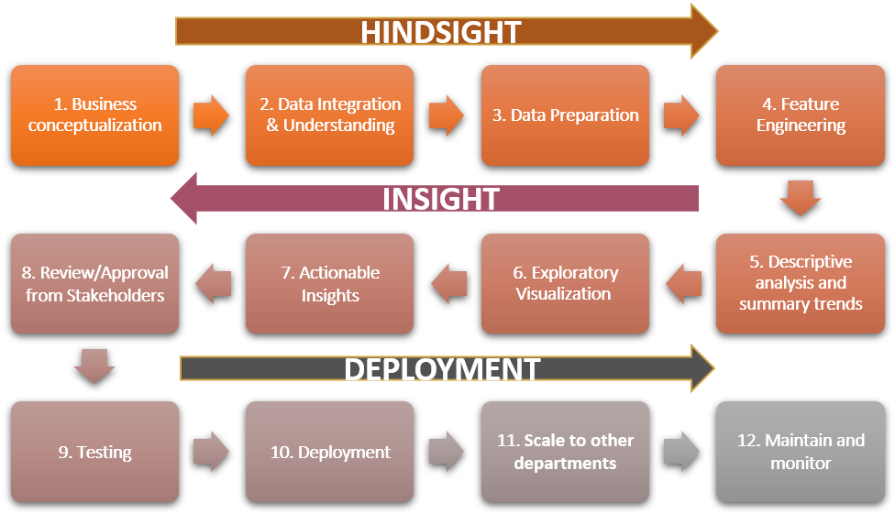 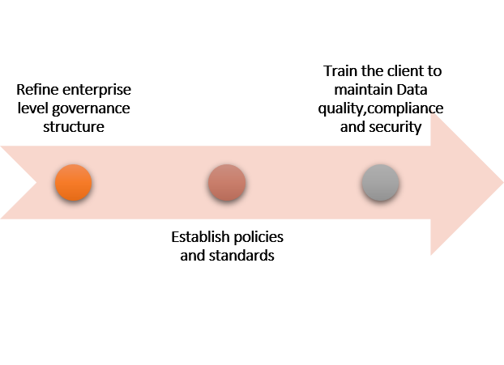

1. Scope of work

In this engagement, we’ll will be engaged in setting up a governance structure for their analytics wing. Simultaneously, part of our team will conduct a POC for their newly generated data science arm where we’ll be engaging in exploratory data analysis to obtain actionable insights followed by a comprehensive dashboard.

**Departments our team members will be engaged in: -**

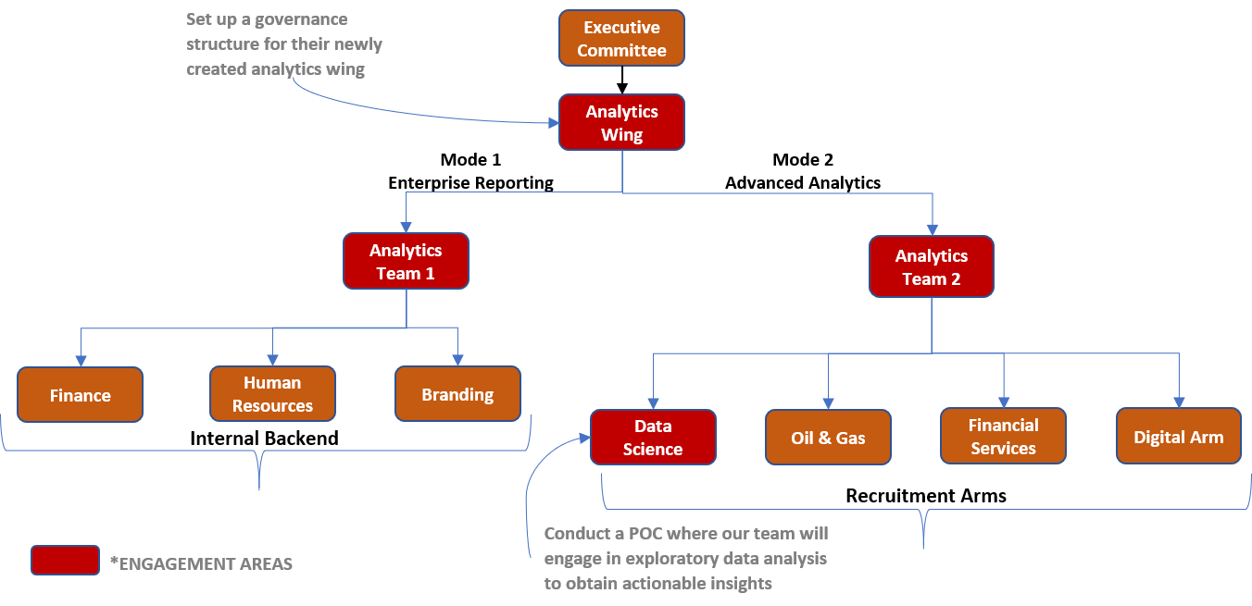

**Governance Structure**

We will be evaluating the current analytics maturity of the firm, assess how other industry recruitment arms (like financial services, digital, etc) operate. Post our assessment we will layout an **‘To-be’** governance structure for their centralized analytics wing.

In order to get better traction, we will create separate working environments - Mode 1 and Mode 2 analytics by establishing a tiered BI (Business Intelligence) and analytics platform.

**Mode 1** will be more stable, reliable, and high performance for **enterprise reporting**, whereas

**Mode 2** will deliver innovative, flexible, and quick-turnaround analytics services for **augmented data discovery and process automation.**

**Descriptive**

We will be sourcing 4 sample data sets on job postings of Data Analysts, Business Analysts, Data Scientists and Data Engineers. Using **Trifacta software tool**, we will be exploring the combined dataset followed by holistic dashboard using **Tableau.**

**Diagnostic**

Depending on data the we’ll perform several statistical tests such as annova, t-test, z-test, chi-test to assess strength of relationship between your target variables and features.

1. Key Deliverables

Final list of outcomes for management

|  |  |
| --- | --- |
| **Deliverable** | **Description** |
| Analytics Communication & Training | Conduct webinars and workshops on importance of Data Analytics among higher management and how analytics can contribute in achieving business objectives. This will help see investment in analytic solutions as a revenue generating asset rather than a cost |
| Dashboard Presentation | Display actionable insights from our analysis and visualization of the data |
| Data Governance Change Management Presentation | Showcase our approach to create the enterprise level governance structure for any future analytic projects which will be done by GoRecruit |

1. Effort Estimates and Timeline

**August**  **September**



1. References
   * + - The dataset was created by “picklesueat” and contains more than 2000 job listing for data analyst positions. <https://github.com/picklesueat/data_jobs_data>

* Gartner Analytics report - Magic quadrant for analytics